**National University of Computer & Emerging Sciences**



**Project Report**

**MedConnect:**

**A Trusted Pharmaceutical Supply-chain Mechanism**

**Project Supervisor Submitted by**

Sir Shahbaz Siddique Afzal Ali Solangi

21K-4077

# Table of Contents

**1. Abstract: 3**

**2. Introduction: 3**

**3. Background and related work 4**

**4. Methodology 5**

**4.1. Tools 5**

**4.2. Software Development Process 5**

**5. Use Cases of the Application 6**

**5.1. Use Case #01 User Sign-Up Process 7**

**5.1.1. Manufacturer Sign-Up Process 7**

**5.1.2. Distributor Sign-Up Process 10**

**5.1.3. Drug Store Sign-Up Process 13**

**5.2. Use Case #02 User Manufacturer Adds an Item Process 16**

**5.3. Use Case #03 User Distributor Orders Product 20**

**5.4. Use Case #04 User Distributor Ordered Product Verification Process 23**

**6. Conclusion and Future Work 26**

**6.1. Conclusion 26**

**6.2. Future Work 26**

**i. Integration with IoT Devices 26**

**ii. Smart Contract Optimization 27**

**iii. Collaboration with Regulatory Bodies 27**

**iv. User-Friendly Interfaces 27**

**v. Scalability and Network Consensus 27**

**7. References 28**

# Abstract:

**In order to prevent and treat illnesses and ailments that pose a serious threat to life, life-saving drugs are required. These drugs have the power to significantly impact someone's quality of life and possibly influence whether they will live or die. Drugs that can save lives are frequently used to treat chronic diseases like diabetes, heart disease, and cancer. These diseases can become deadly if untreated. The use of life-saving drugs, however, enables people to manage these illnesses and stop them from getting worse, allowing them to live longer, healthier lives. The recent expansion of the black market for drugs in Pakistan, which has resulted in a rise in fake drugs and a shortage of necessary prescriptions from the market, must be noted. This is a result of the country's dire economic situation. Due to this Patients now face more difficulties in getting the necessary care. One of the causes of this is the absence of government regulation of the pharmaceutical industry, which has allowed dishonest practices like the use of antiquated documentation techniques to persist. Demand-supply activities need to be safely automated in order to solve this problem. A more open and effective pharmaceutical supply chain can be created by using modern techniques and technology, like blockchain. This can lessen corruption and guarantee that people in need of life-saving pharmaceuticals can get them. In this project, we implement a proof-of-concept for a medicine demand-supply system based on blockchain that makes use of smart contracts to enforce dynamic policies and preserve the integrity of the supply chain.**

# Introduction:

**The healthcare sector is a vast and intricate network of interconnected disciplines and systems, each of which is vital to maintaining and improving human lives. Since any disruption or failure in its intricate ecology might have catastrophic implications for individuals and communities, the healthcare system is therefore inherently susceptible[1]. The delicate interplay of resources, infrastructure, expertise, and empathy that makes up this vital sector influences the wellbeing of millions of people, underscoring the critical need to guarantee its resilience and adaptation in the face of challenges and unpredictability. When someone has a life-threatening condition, medications are without a doubt their lifeline[2]. The crucial task of providing vital therapies to individuals in need is supported by the medication supply chain, which acts as the fundamental foundation of our healthcare system. In the absence of a dependable and secure supply chain for drugs, the whole healthcare system is vulnerable to collapse. Since any breach might have disastrous repercussions, the integrity of this supply chain is crucial. The constant supply of these life-saving medications is crucial for saving lives and ensuring the safety and wellbeing of countless people[3].**

**Eliminating the distribution of counterfeit medications is one strategy to improve the integrity of the healthcare system since these products represent a serious risk to patient health and undermine the pharmaceutical industry's reputation[4]. Making sure there is a dearth of life-saving medication available on the market is another way to have a system in place to deal with drug hoarders who want to sell their possessions at higher prices in the future. Unfortunately, there has been a growth in fake medications in Pakistan over the last several years, as well as a market scarcity. To keep enough medications on the market, these issues demand a strong solution that checks the validity of the medications as they travel from producer to pharmacy and ultimately to the end user[5].**

**This project makes use of blockchain technology to overcome these concerns. Blockchain technology has generated a great deal of attention as a potentially efficient means to enhance security across a variety of organizations, and it has immense potential to solve difficulties with the authenticity of pharmaceuticals. The major benefit of blockchain is its immutable ledger, which ensures high levels of openness and trust since data once recorded cannot be altered or deleted. According to this, the pharmaceutical industry's whole supply chain, from manufacture to distribution, may be securely recorded[6]. This kind of unbreakable, transparent ledger may help to verify that drugs are authentic and haven't been altered illegally or counterfeited. By improving consumer trust and, more importantly, safeguarding patients, this technology has the potential to revolutionize the way that pharmaceuticals are validated[7].**

1. Background and related work**:**

**To improve transparency in the pharmaceutical supply chain, a group of pharmaceutical companies and technology providers called PharmaLedger has collaborated. This initiative utilizes blockchain technology to make the pharmaceutical sector more transparent, secure, and efficient. By leveraging smart contracts and the immutable ledger of the blockchain, PharmaLedger aims to enhance traceability, reduce prescription fraud, and streamline regulatory compliance across the pharmaceutical supply chain[8.9.10,11,12]. MediLedger is one of the first blockchain technologies created specifically for the pharmaceutical sector. With a focus on adhering to the Drug Supply Chain Security Act (DSCSA) in the US, MediLedger provides a robust platform that ensures the authenticity of pharmaceutical products[13,14,15,16]. Smart contracts and blockchain technology have improved supply chain security by enabling stakeholders to monitor the integrity of drugs at every stage of their journey. IBM Blockchain for Pharmaceuticals is a cutting-edge technology that is set to revolutionize how pharmaceutical supply chains are managed. Through this initiative, pharmaceutical products can be monitored and traced from start to finish, guaranteeing compliance with stringent regulatory criteria. IBM's smart contract solutions provide industry stakeholders with greater control by enhancing real-time visibility, data integrity, and operational performance[17,18]. Modum combines IoT and blockchain to provide state-of-the-art supply chain monitoring solutions for the pharmaceutical industry. Their smart contracts enable real-time tracking and monitoring of temperature-sensitive medicinal products during transportation. To maintain product quality and compliance, Modum integrates pharmaceutical integrity throughout the course of the drug[19,20]**

|  |  |  |
| --- | --- | --- |
| **Application Name** | **Features** | **Gaps** |
| **Pharma Ledger** | * **Traceability** * **Counterfeit Prevention** * **Data Integrity** | * **Interoperability** * **Data Privacy** * **Regulatory Compliance** |
| **MediLedger** | * **Product Authentication** | * **Regulatory Compliance** |
| **IBM Blockchain** | * **End-to-End Tracking** * **Real-Time Monitoring** | * **Regulatory Compliance** |
| **Modum** | * **Temperature Tracking** * **Data Integrity** | * **Regulatory Compliance** * **Limited Application** |

**Table -1 Comparative Assessment of available Features**

**The aforementioned applications are clearly decentralized, and according to a literature assessment of them, they are largely concerned with boosting security in the pharmaceutical supply chain process by utilizing smart contracts and service level agreements. But a significant shortcoming is the lack of regulatory smart contracts designed specifically to solve problems with fake medications and shortages of pharmaceuticals.**

1. Methodology**:**
   1. Tools**:**

**Following are the tools used for this project:**

1. **Multichain 4. Bootstrap 7. JavaScript**
2. **Django 5. Flutter**
3. **Python 6. Firebase**
   1. Software Development Process**:**

**For this project Agile development process will be used. Agile is a software development process that emphasizes customer-centricity, teamwork, and continuous improvement. It involves dividing large projects into smaller, easier to manage chunks known as iterations or sprints and delivering functional software at the end of each one. Agile emphasizes the value of client feedback, welcomes changing needs even late in the development process, and encourages open communication. It is a paradigm that promotes self-organizing teams that collaborate to provide value by placing a higher value on people and interactions than on processes and tools. With Agile, the emphasis is on producing a product that closely matches the needs of the client, encouraging adaptability, and making sure that the software remains relevant in a constantly shifting environment.**

1. Use Cases of the Application: 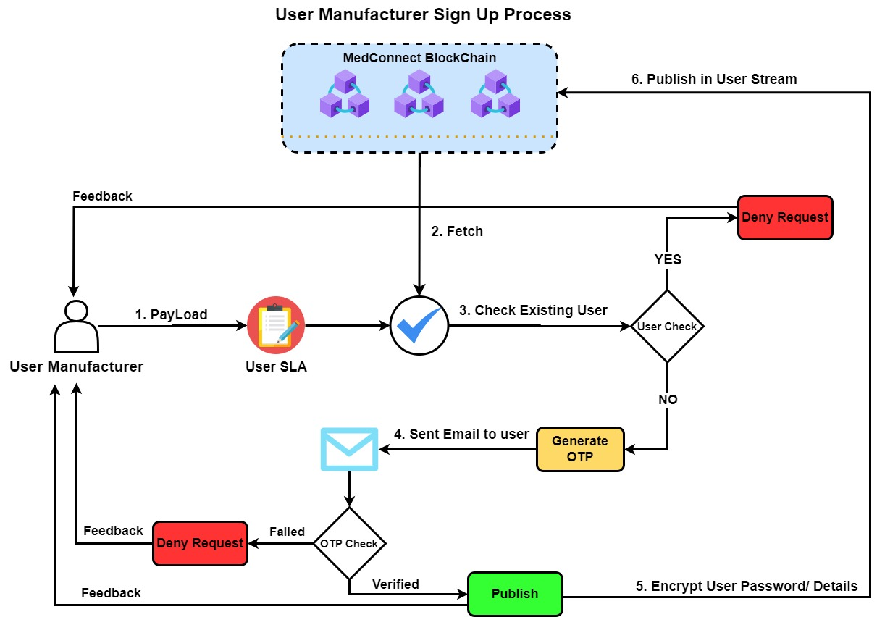

**Figure 1 User Manufacturer Sign Up Process**

* 1. Use Case #01 User Sign-Up Process**:**

The purpose is to leverage blockchain technology to improve the application's user registration procedure. With a focus on boosting user experience overall, the goal is to establish a solution that addressed data security, transparency, and privacy of users. Conventionally, user registration procedures frequently depend on centralized authorities, which presents inherent privacy and data security vulnerabilities. By using blockchain technology, a decentralized identity management system was established, giving users total control over their personal data and eliminating the need for a centralized authority. Users create a safe digital identity during registration, which is cryptographically recorded on the blockchain to guarantee the integrity and immutability of the data. This strategy reduced the possibility of both data breaches and illegal access. By adding smart contracts, verification procedures were further automated and improved, increasing the efficiency of user onboarding. By using blockchain technology, the application's security is strengthened and user confidence is raised, thereby creating a new benchmark for impartial and effective user registration procedures in the digital sphere.

In the following following sections we are going to discuss the detailed steps how this case study is implemented in a practical manner:

* + 1. Manufacturer Sign-Up Process**:**
* The user provides personal details such as
  + Company Information
  + Contact Information
  + Business Details
  + Company Profile
  + License and Certification
* The user sets a secure password.
* User completes the checkbox challenge for Human Verification.
* The user must agree to the Terms and Conditions of the Platform by checking the checkbox.
* The JSON pay load then will be sent to the system.
* The request will be encrypted with the public key of Medconnect blockchain using ECC suit.

|  |  |  |
| --- | --- | --- |
|  |  | Equation(1) |
|  |  |  |

$$\left\{\begin{aligned}Request=Sign up Manufacturer \\ User SLA=User Service license agreement \\ Data=User Information for Manufaturer\end{aligned}\right.$$

* The PayLoad is then decrypted using the Private key of Medconnect blockchain.

|  |  |  |
| --- | --- | --- |
|  |  | Equation(2) |
|  |  |  |

* The system fetches the Hashed User SLA from the Medconnect blockchain.

|  |  |  |
| --- | --- | --- |
|  | $$Fetch={\{HASHED(User SLA)\}}_{}$$ | Equation(3) |
|  |  |  |

$$\left\{HASHED=calculated Hash from Medconnect Blockchain\right.$$

* The system first initiates a verification process to confirm the **User’s** identity in accordance with a User Service Level Agreement (SLA).
* The decrypted User SLA from the PayLoad is compared with the hash of User SLA from Fetch.

|  |  |  |
| --- | --- | --- |
|  | $$Fetch(HASHED(User SLA)==PayLoad(HASHED(User SLA))$$ | Equation(4) |

* Following the SLA verification, the system checks whether user email is already present in the **User Stream.**

|  |  |  |
| --- | --- | --- |
|  | $$Fetch(Data\left[email address\right])==PayLoad(Data\left[email address\right])$$ | Equation(5) |

* If the user is already present in the **User Stream**, the process stops and feedback is sent back to the user that the request has been denied and the user is already register or prompt the user to use a different email or offer a password recovery option.
* If the user is not present in the **User Stream**, the system generates an OTP code and sends it to the user email address.

|  |  |  |
| --- | --- | --- |
|  |  | Equation(6) |

* The user enters the received OTP code in the input field of the UI.
* Upon successful verification of the OTP code, system proceeds to encrypting the User details and then publishes it into the **User Stream**.
* Upon failed verification of the OTP, system prompts the user verification failed and the option to generate new OTP to be sent to the user email address.
* Following the successful verification of OTP, the system sends a welcome email to the user, providing essential information about the platform, additional steps, or resources.

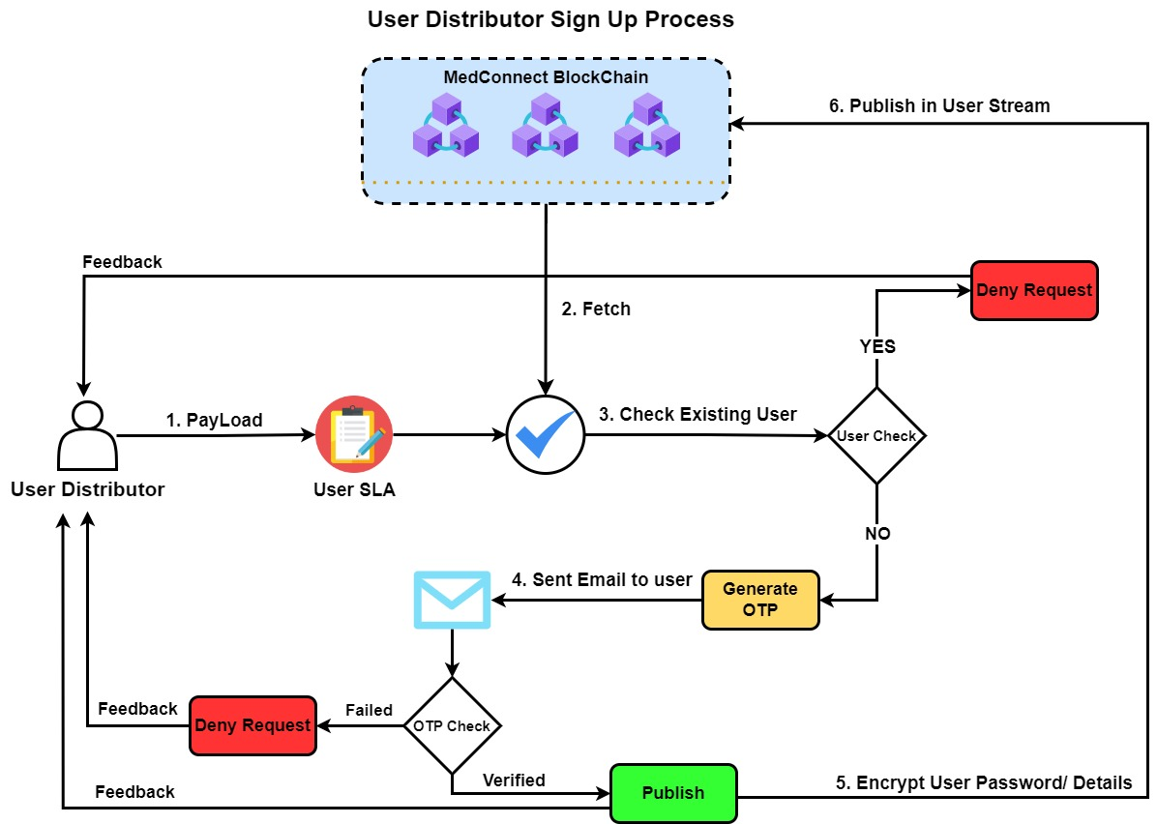

**Figure 2 User Distributor Sign Process**

* + 1. Distributor Sign-Up Process**:**
* The User provides details such as:
  + Company name
  + Business Registration Number
  + Business Address
  + Business registration
  + Contact Information
  + License and Certification
  + Distribution Network Overview
  + Types of Medicines Distributed
  + Brands Represented
  + Licenses and Certifications
* The user sets a secure password.
* User completes the checkbox challenge for Human Verification.
* The user must agree to the Terms and Conditions of the Platform by checking the checkbox.
* The JSON pay load then will be sent to the system.
* The request will be encrypted with the public key of Medconnect blockchain using ECC suit.

|  |  |  |
| --- | --- | --- |
|  |  | Equation(7) |
|  |  |  |

$$\left\{\begin{aligned}Request=Sign up Distributor \\ User SLA=User Service License Agreement \\ Data=User Information for Distributor\end{aligned}\right.$$

* The PayLoad is then decrypted using the Private key of Medconnect blockchain.

|  |  |  |
| --- | --- | --- |
|  |  | Equation(8) |
|  |  |  |

* The system fetches the Hashed User SLA from the Medconnect blockchain.

|  |  |  |
| --- | --- | --- |
|  | $$Fetch={\{HASHED(User SLA)\}}_{}$$ | Equation(9) |
|  |  |  |

$$\left\{HASHED=calculated Hash of User SLA from Medconnect Blockchain\right.$$

* The system first initiates a verification process to confirm the **User’s** identity in accordance with a User Service Level Agreement (SLA).
* The decrypted User SLA from the PayLoad is compared with the hash of User SLA from Fetch.

|  |  |  |
| --- | --- | --- |
|  | $$Fetch(HASHED(User SLA)==PayLoad(HASHED(User SLA))$$ | Equation(10) |

* Following the SLA verification, the system checks whether user email is already present in the **User Stream.**

|  |  |  |
| --- | --- | --- |
|  | $$Fetch(Data\left[email address\right])==PayLoad(Data\left[email address\right])$$ | Equation(11) |

* If the user is already present in the **User Stream**, the process stops and feedback is sent back to the user that the request has been denied and the user is already register or prompt the user to use a different email or offer a password recovery option.
* If the user is not present in the **User Stream**, the system generates an OTP code and sends it to the user email address.

|  |  |  |
| --- | --- | --- |
|  |  | Equation(12) |

* The user enters the received OTP code in the input field of the UI.
* Upon successful verification of the OTP code, system proceeds to encrypting the User details and then publishes it into the **User Stream**.
* Upon failed verification of the OTP, system prompts the user verification failed and the option to generate new OTP to be sent to the user email address.
* Following the successful verification of OTP, the system sends a welcome email to the user, providing essential information about the platform, additional steps, or resources.

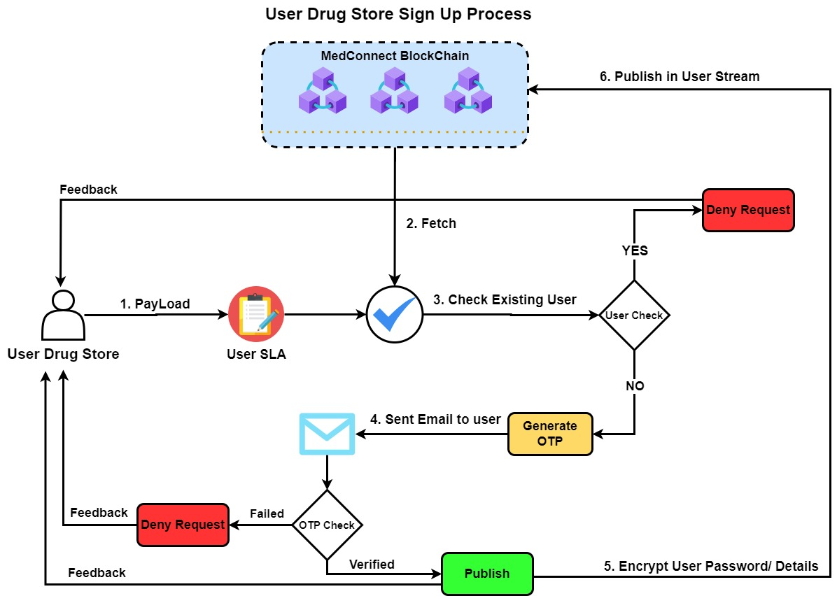

**Figure 3 User Drug Store Sign Up Process**

* + 1. Drug Store Sign-Up Process**:**
* The User provides details:
  + Store name
  + Address
  + Contact Information
  + Business registration
  + Company Profile
  + License and Certification
  + Representative Information
  + Drug store type (Hospital Pharmacy, Clinical Pharmacy, retail pharmacy, etc.)
* The user sets a secure password.
* User completes the checkbox challenge for Human Verification.
* The user must agree to the Terms and Conditions of the Platform by checking the checkbox.
* The JSON pay load then will be sent to the system.
* The request will be encrypted with the public key of Medconnect blockchain using ECC suit.

|  |  |  |
| --- | --- | --- |
|  |  | Equation(13) |
|  |  |  |

$$\left\{\begin{aligned}Request=Sign up Drug Store \\ User SLA=User Service license agreement \\ Data=User Information for Drug Store\end{aligned}\right.$$

* The PayLoad is then decrypted using the Private key of Medconnect blockchain.

|  |  |  |
| --- | --- | --- |
|  |  | Equation(14) |
|  |  |  |

* The system fetches the Hashed User SLA from the Medconnect blockchain.

|  |  |  |
| --- | --- | --- |
|  | $$Fetch={\{HASHED(User SLA)\}}_{}$$ | Equation(15) |
|  |  |  |

$$\left\{HASHED=calculated Hash from Medconnect Blockchain\right.$$

* The system first initiates a verification process to confirm the **User’s** identity in accordance with a User Service Level Agreement (SLA).
* The decrypted User SLA from the PayLoad is compared with the hash of User SLA from Fetch.

|  |  |  |
| --- | --- | --- |
|  | $$Fetch(HASHED(User SLA)==PayLoad(HASHED(User SLA))$$ | Equation(16) |

* Following the SLA verification, the system checks whether user email is already present in the **User Stream.**

|  |  |  |
| --- | --- | --- |
|  | $$Fetch(Data\left[email address\right])==PayLoad(Data\left[email address\right])$$ | Equation(17) |

* If the user is already present in the **User Stream**, the process stops and feedback is sent back to the user that the request has been denied and the user is already register or prompt the user to use a different email or offer a password recovery option.
* If the user is not present in the **User Stream**, the system generates an OTP code and sends it to the user email address.

|  |  |  |
| --- | --- | --- |
|  |  | Equation(18) |

* The user enters the received OTP code in the input field of the UI.
* Upon successful verification of the OTP code, system proceeds to encrypting the User details and then publishes it into the **User Stream**.
* Upon failed verification of the OTP, system prompts the user verification failed and the option to generate new OTP to be sent to the user email address.
* Following the successful verification of OTP, the system sends a welcome email to the user, providing essential information about the platform, additional steps, or resources.

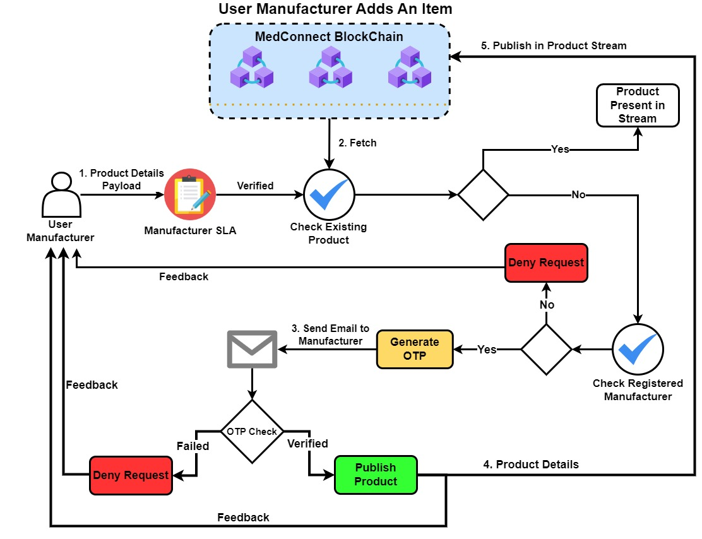

**Figure 4 User Manufacturer Adds an Item Process**

* 1. Use Case #02 User Manufacturer Adds an Item Process**:**

This application is designed to enable a manufacturer to integrate its production processes into a blockchain in an effort to increase efficiency of the pharmaceutical supply chain and guaranteeing security and transparency in the supply chain. By using an architecture which uses decentralized system that makes use of blockchain technology with the goal of improving the traceability and integrity of the procedures involved in making medicines. The application's user manufacturer smoothly integrated each stage of the medication creation process, producing an unchangeable and visible record of each step. Through the implementation of cryptography, the application is able to secure the entire supply chain, from the Production to end user, from illegal modifications and counterfeiting. In addition to lowering the possibility of data manipulation, blockchain technology's decentralized structure allows for real-time visibility for all parties participating in the pharmaceutical supply chain. Using smart contracts, compliance verification is automated, guaranteeing that regulations were followed at all times. In addition to improving the security and accountability of the pharmaceutical manufacturing process, revolutionizes and establishes a standard for transparency in the pharmaceutical supply chain.

In the following section we are going to discuss the detailed steps how this case study is implemented in a practical manner:

* The **User Manufacturer** submits the details of the product:
  + Product Name
  + Dosage
  + Manufacturer Information
  + Brand Name
  + Expiry Date
  + Manufacturing Date
  + Ingredients
  + Batch Number
  + Barcodes
  + Regulatory Approvals
  + Price
  + Availability
* **User manufacturer** completes the checkbox challenge for Human Verification.
* The JSON pay load containing the Product information is then sent to the system.
* The request will be encrypted with the public key of Medconnect blockchain using ECC suit.

|  |  |  |  |
| --- | --- | --- | --- |
|  |  |  | Equation(19) |
|  |  |  |  |

$$\left\{\begin{aligned}Request=Publish Drug \\ Manufacturer SLA=Manufacturer Service License Agreement \\ Data=Drug Information\end{aligned}\right.$$

* The PayLoad is then decrypted using the Private key of Medconnect blockchain.

|  |  |  |
| --- | --- | --- |
|  |  | Equation(20) |
|  |  |  |

* The system fetches the Hashed User SLA from the Medconnect blockchain.

|  |  |  |
| --- | --- | --- |
|  | $$Fetch={\{HASHED(Manufacturer SLA)\}}_{Encrypt(Manufacturers Public key)}$$ | Equation(21) |
|  |  |  |

$$\left\{HASHED=calculated Hash from Medconnect Blockchain\right.$$

* The Fetch is then decrypted using the private key of Manufacturer

|  |  |  |
| --- | --- | --- |
|  | $$Fetch={\{HASHED(Manufacturer SLA )\}}_{decrypt(Manufacturers Private key)}$$ | Equation(22) |

* The system first initiates a verification process to confirm the **User Manufacturer’s** identity in accordance with a Manufacturer Service Level Agreement (SLA).
* The decrypted Manufacturer SLA from the PayLoad is compared with the hash of Manufacturer SLA from Fetch.

|  |  |  |
| --- | --- | --- |
|  | $$Fetch(HASH(Manufacturer SLA)==PayLoad(HASHED(Manufacturer SLA))$$ | Equation(23) |

* Following the SLA verification, the system checks whether the product is already present in the **Product Stream** by comparing the decrypted from both Fetch and PayLoad**.**

|  |  |  |
| --- | --- | --- |
|  | $$Fetch(Data\left[Product Code\right])==PayLoad(Data\left[Product Code\right])$$ | Equation(24) |

* If the product is present in the **Product stream**, the user is prompted to edit the quantity of that specific product only.
* If the product is not present in the stream, the system checks if the product which is being added is a Government registered product.
* If the product is a registered, then the system generates an OTP code and User Manufacturer will be sent an email with the OTP code.

|  |  |  |
| --- | --- | --- |
|  |  | Equation(25) |
|  |  |  |

* Upon failed verification of the OTP, system will prompt the user verification failed and the option to generate another OTP to be sent to the user email address.
* Upon successful verification of the OTP code, system proceeds to product details will be published on the **Product stream**.

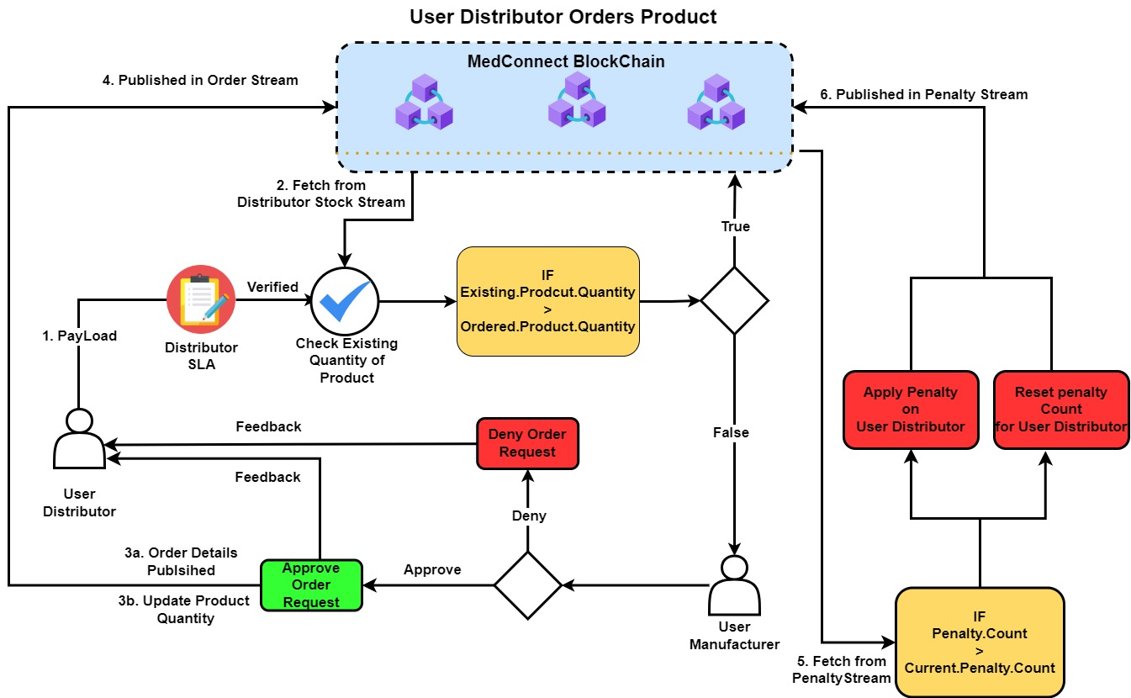

**Figure 5 User Distributor Orders Product**

* 1. Use Case #03 User Distributor Orders Product**:**

This project integrates blockchain technology into their ordering operations, to increase the integrity and efficiency of the pharmaceutical supply chain. The user distributor orders and tracks products straight from the manufacturer. This creative method makes it possible to record every step of the distribution process from placing the order to delivering the product in an unchangeable and transparent manner. In order to automate order verification and guarantee adherence to industry norms and laws, smart contracts are implemented. The user distributor's activities are made more efficient by the integration making the pharmaceutical supply chain safer and more transparent.

In the following section we are going to discuss the detailed steps how this case study is implemented in a practical manner:

* The **User Distributor** is able to select the product or products from the Web UI to order; the product details are fetched form the **product stream**.
* Selected products are added into the cart containing information such as:
  + Product Id
  + Product Name
  + Quantity
  + Product Price
  + Subtotal
  + Total
* The **User Distributor** proceeds to the Checkout stage following the selection of products.
* On Checkout stage the **User Distributor** completes the Checkbox challenge for Human Verification.
* After the clicks **User Distributor** clicks on the “Place Order”, the system is sent the JSON payload containing order information.
* The request will be encrypted with the public key of Medconnect blockchain using ECC suit.

|  |  |  |  |
| --- | --- | --- | --- |
|  |  |  | Equation(26) |
|  |  |  |  |

$$\left\{\begin{aligned}Request=Publish Drug \\ Distributor SLA=Distributor Service License Agreement \\ Data=Order Information\end{aligned}\right.$$

* The PayLoad is then decrypted using the Private key of Medconnect blockchain.

|  |  |  |
| --- | --- | --- |
|  |  | Equation(27) |
|  |  |  |
|  |  |  |

* The system fetches the Hashed User SLA from the Medconnect blockchain.

|  |  |  |
| --- | --- | --- |
|  | $$Fetch={\{HASHED(Manufacturer SLA)\}}_{}$$ | Equation(28) |
|  |  |  |

$$\left\{HASHED=calculated Hash from Medconnect Blockchain\right.$$

* The system first initiates a verification process to confirm the **User Manufacturer’s** identity in accordance with a Manufacturer Service Level Agreement (SLA).
* The decrypted Manufacturer SLA from the PayLoad is compared with the hash of Manufacturer SLA from Fetch.

|  |  |  |
| --- | --- | --- |
|  | $$Fetch(HASH(Manufacturer SLA)==PayLoad(HASHED(Manufacturer SLA))$$ | Equation(29) |

* The system compares the quantity of the selected product or products by fetching the product or products quantity from the of **Distributor Stock Stream** with the quantity of the product or products requested by the Distributor.

|  |  |  |
| --- | --- | --- |
|  | $$Paylaod\left(Ordered Quantity\right)<Fetch(Product Quantity)$$ | Equation(30) |

* If the existing product quantity is greater than ordered product quantity. The system applies implement penalty against that distributor and record it in the **penalty stream**.
* Another check then is performed in which the current penalty count for the **User Distributor** is greater than some variable Penalty count specified in the system. Then a penalty against the **User distributor** is issued and the penalty counter for that particular **User Distributor** gets reset.
* If the existing product quantity is lesser than ordered quantity. The system will proceed and the order request will then be passed to the **User Manufacturer**, who will approve or disapprove the order.
* If the order is approved by the User manufacturer, the quantity for the selected products will get updated in the **Product Stream** and the order is published in the **Order stream**.
* The **User Distributor** is then allowed to place another order after 24 Hours, as it can place multiple orders by-passing the checks.

**Figure 6 User Distributor Ordered Product Verification Process**

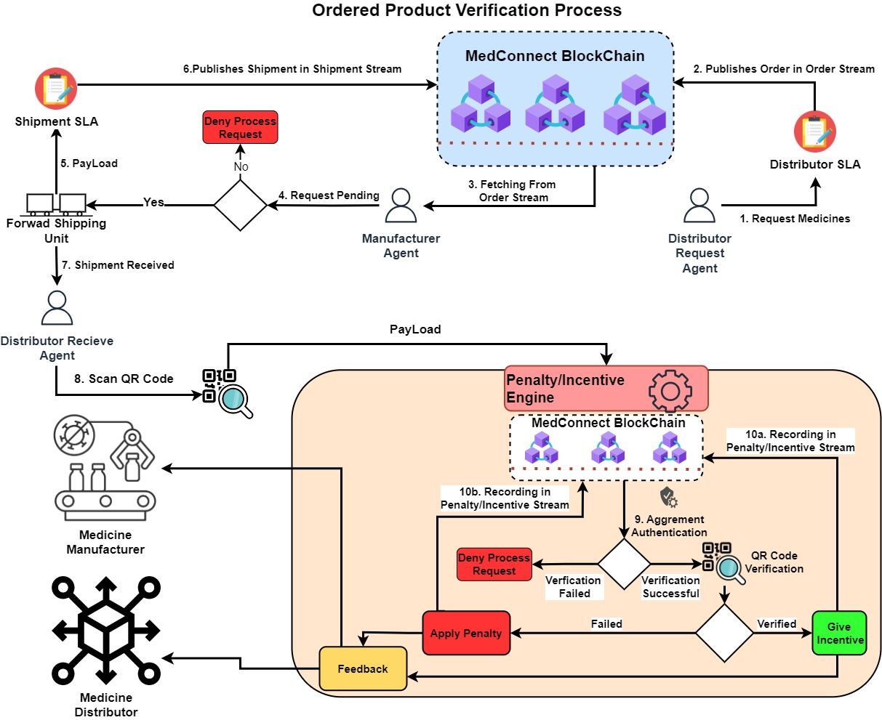

* 1. Use Case #04 User Distributor Ordered Product Verification Process**:**

In this project user distributor is capable of easily verifying requested items through the use of blockchain technology. By implementing a decentralized system since it is very for the distribution process in the supply chain to be transparent and accountable. By utilizing blockchain technology, user distributor is able to easily confirm every stage of the product's journey, from manufacturing to delivery. Every transaction and movement is documented in the transparent and unchangeable ledger, guaranteeing the integrity of the medicinal products that are ordered. In addition to giving distributors real-time supply chain access, this reduces the possibility of unauthorized changes and counterfeit goods. The blockchain's decentralized structure improved data security by lowering the possibility of fraud and mistakes during the verification process. Verification processes is automated through the use of smart contracts, which streamlines compliance checks and guarantees conformity to industry standards. Consequently, the adoption of blockchain technology enhances the user distributors' verification process.

In the following following section the detailed steps of how this case study is implemented in a practical manner:

* The User Distributor places an order through **User Distributor Orders Product Process**, which publishes the order in the **Order Stream**.
* The order is fetched from the **Order Stream** through **User Distributor Orders Product Process.**

|  |  |  |
| --- | --- | --- |
|  |  | Equation(31) |

$\left\{\begin{aligned}Request=Get Order \\ Data=Order Information\end{aligned}\right.$

* The Fetch is then decrypted at the Manufacturer side using the Manufacturer Private key.

|  |  |  |
| --- | --- | --- |
|  |  | Equation(32) |
|  |  |  |

* The order request Fetch is then received by the **Manufacturer Agent**.
* After the order request is approved by the **Manufacturer Agent**, the products are prepared and handed over to shipping unit.
* The information of the shipping unit is published into the **Shipping stream** including details like:
  + Shipping Id
  + Carrier
  + Tracking Number
  + Estimated Arrival
  + Shipping Address
  + Shipping Cost
  + Items
  + Status
  + Shipping Method

|  |  |  |
| --- | --- | --- |
|  |  | Equation(33) |

$$\left\{\begin{aligned}Request=Get Order \\ Data=Shipment Information Information\end{aligned}\right.$$

* Once the Shipment Information is Published, the QR code is generated using a python Library “qrcode[pil]”, the QR code is generated on the unique Transaction ID generated from the chain.
* The QR Code is sticker on the packaging of the prepared ordered.
* Upon receiving the order by the **Distributor Agent**, the QR Code on the package is scanned.
* The Penalty/ Incentive Unit verifies the order agreement between the Distributor and the Manufacturer.
* If the Agreement verification fails, the process request is denied.
* Following the Successful Agreement verification, the QR code on the packaging is matched with the QR code for that order published in the **Shipping Stream**.
* The QR Code is then sent to the system.

|  |  |  |
| --- | --- | --- |
|  |  | Equation(34) |

$$\left\{\begin{aligned}Request=QR Code Verify \\ Data=QR Code\end{aligned}\right.$$

* The PayLoad is decrypted the Medconnect Blockchain side using the Medconnect Private Key.

|  |  |  |
| --- | --- | --- |
|  |  | Equation(35) |

$$\left\{\begin{aligned}Request=QR Code Verify \\ Data=QR Code\end{aligned}\right.$$

* The text generated from the QR Code is checked if the any shipment is present in the **Shipment Stream**.

|  |  |  |
| --- | --- | --- |
|  | $$Medconnect.Client(Transaction Id)$$ | Equation(36) |

$$\left\{Transaction Id=PayLoad(Data)\right.$$

* If the QR code is verified the **Manufacturer** is given some variable incentive, which gets published in the **Penalty/ Incentive stream** and feedback is sent to both parties.
* If the QR code fails, the penalty is recorded in the **Penalty/ Incentive stream** for the manufacturer, and feedback is sent to the both parts
* The above steps assure that the Order is genuine and has a valid track histroy present in the Medconnect Blockchain.

1. Conclusion and Future Work**:**
   1. Conclusion**:**

At the end of the day, it is impossible to overestimate the vital role that life-saving medications play in both preventing and treating major illnesses. The current problems facing Pakistan's healthcare system is the increase of fake medications and the scarcity of necessary prescriptions as a result of the growing black market. This major issue produces critical need for a strong and safe pharmaceutical supply chain which is capable of tackling this issue.

Since there is absolutely no government control of the pharmaceutical sector, dishonest practices have been permitted to continue, putting patient’s health at serious jeopardy. The blockchain is invention of modern technology and appears to be a possible solution to the problems faced by pharmaceutical sector of Pakistan. This project's proof-of-concept describes a blockchain based medical demand supply system that uses smart contracts to impose dynamic rules and maintain the reliability of the whole supply chain.

The properties of blockchain technology, such as its transparent and unchangeable ledger, prove to be a potential game-changer in the fight against fake pharmaceuticals. Blockchain technology can authenticate pharmaceuticals and ensure they haven't been tampered with or counterfeited by securely recording the whole pharmaceutical supply chain, from manufacturing to distribution and keeping the track of the pharmaceuticals stocked in the market, to make sure no pharmaceuticals shortage occurs through an automated system of maintain decent quantity of pharmaceuticals in the market. By utilizing the Blockchain in such a way transforms pharmaceuticals supply chain and more crucially, protects patients wellbeing while also increasing customers trust.

The implementation of blockchain technology in pharmaceutical supply chains is very important in the constantly changing healthcare landscape. It is a step toward creating a healthcare system that is adaptable and robust to overcome obstacles and guarantee the safe, ongoing supply of life-saving drugs to individuals who require them.

* 1. Future Work**:**

In future several paths can be explored for this project to enhance and improve the effectiveness of the Blockchain-based Pharmaceuticals demand supply chain system:

1. Integration with IoT Devices**:**

Examine how to include Internet of Things (IoT) sensors to track temperature, humidity, and other environmental factors when storing and transporting medications. The data from IoT sensors can be stored on the blockchain, increasing the level of transparency and guaranteeing the pharmaceuticals' integrity.

1. Smart Contract Optimization**:**

Smart contracts can be further improved and optimized to handle complex situations in the pharmaceutical supply chain. Creating dynamic smart contracts that are capable of adjusting to shifting market conditions, legal specifications, etc.

1. Collaboration with Regulatory Bodies**:**

Form partnerships with government organizations and regulatory entities to guarantee adherence to current regulations and standards. By functioning as an auditable and transparent platform, the blockchain technology can help with regulatory supervision and increase accountability throughout the pharmaceutical supply chain.

1. User-Friendly Interfaces**:**

To create User interfaces that are easy to use for all parties engaged in the pharmaceutical supply chain, including regulators, manufacturers, distributors, and pharmacists. Making it easier to engage with the blockchain system can promote wider adoption and enable smooth communication between users.

1. Scalability and Network Consensus**:**

To address the blockchain's scalability issues in order to handle the growing number of transactions in the pharmaceutical supply chain. Examine several consensus techniques to make sure the system stays responsive and functional regardless of how it grows to cope with more users and transactions.

1. References**:**
2. Nanda, Saroj Kumar, Sandeep Kumar Panda, and Madhabananda Dash. "Medical supply chain integrated with blockchain and IoT to track the logistics of medical products." *Multimedia Tools and Applications* (2023): 1-23.
3. Fiore, M., Capodici, A., Rucci, P., Bianconi, A., Longo, G., Ricci, M., ... & Golinelli, D. (2023). Blockchain for the healthcare supply chain: A systematic literature review. *Applied Sciences*, *13*(2), 686.
4. Ghadge, Abhijeet, et al. "Blockchain implementation in pharmaceutical supply chains: A review and conceptual framework." *International Journal of Production Research* 61.19 (2023): 6633-6651.
5. Gruchmann, Tim, Sara Elgazzar, and Ahmed Hussein Ali. "Blockchain technology in pharmaceutical supply chains: a transaction cost perspective." *Modern Supply Chain Research and Applications* (2023).
6. Chen, Xiaohong, et al. "Internet of Things (IoT)—blockchain-enabled pharmaceutical supply chain resilience in the post-pandemic era." *Frontiers of Engineering Management* 10.1 (2023): 82-95.
7. Nanda, Saroj Kumar, Sandeep Kumar Panda, and Madhabananda Dash. "Medical supply chain integrated with blockchain and IoT to track the logistics of medical products." *Multimedia Tools and Applications* (2023): 1-23.
8. Fiore, Matteo, et al. "Blockchain for the healthcare supply chain: A systematic literature review." *Applied Sciences* 13.2 (2023): 686.
9. Ziegler, Yvonne, Vincenzo Uli, and Jan Wortmann. "Blockchain innovation in pharmaceutical use cases: PharmaLedger and Mytigate." *Journal of Supply Chain Management, Logistics and Procurement* 3.4 (2021): 312-325.
10. Balan, Ana, Sînică Alboaie, and Alexandrina Raţă. "PharmaLedger a Blockchain-enabled Healthcare Platform." *2022 E-Health and Bioengineering Conference (EHB)*. IEEE, 2022.
11. Mishra, Vinita, et al. "Pharmaledger-An Improved Solution to identify counterfeit drugs in Supply Chain."
12. Ursache, Cosmin, Michael Sammeth, and Sînică Alboaie. "OpenDSU: Digital Sovereignty in PharmaLedger." *arXiv preprint arXiv:2209.14879* (2022).
13. Kayhan, Halid. "PharmaLedger: Blockchain-Enabled Healthcare: Privacy-Enhancement with Blockchain." *Blockchain in Healthcare Today* (2022).
14. Mattke, Jens, et al. "How an Enterprise Blockchain Application in the US Pharmaceuticals Supply Chain is Saving Lives." *MIS Quarterly Executive* 18.4 (2019).
15. Kombe, Cleverence, Mussa Dida, and Anael Sam. "A review on healthcare information systems and consensus protocols in blockchain technology." (2018).
16. McCurdy, Denise. "Blockchain Governance Strategies." *Blockchain in Life Sciences*. Singapore: Springer Nature Singapore, 2022. 197-212.
17. Woods, Jordan, and Radhika Iyengar-Emens. "Blockchain to secure a more personalized pharma: Digital ledgers can detect fake drugs, enable virtual trials, and advance personalized medicine." *Genetic Engineering & Biotechnology News* 39.1 (2019): 27-29.
18. Ghadge, Abhijeet, et al. "Blockchain implementation in pharmaceutical supply chains: A review and conceptual framework." *International Journal of Production Research* 61.19 (2023): 6633-6651.
19. Lacity, Mary, and Remko Van Hoek. "What we’ve learned so far about blockchain for business." *MIT Sloan Management Review* 62.3 (2021).
20. Bocek, Thomas, et al. "Blockchains everywhere-a use-case of blockchains in the pharma supply-chain." *2017 IFIP/IEEE symposium on integrated network and service management (IM)*. IEEE, 2017.
21. Azzi, Rita, Rima Kilany Chamoun, and Maria Sokhn. "The power of a blockchain-based supply chain." *Computers & industrial engineering* 135 (2019): 582-592.